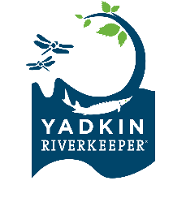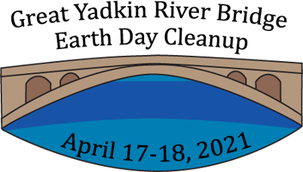

Great Yadkin River Earth Day Bridge Cleanup: General Information and Safety Guidelines
- Please be sure you are registered with Yadkin Riverkeeper for your location.
- Your location should have adequate, safe parking, and safe access to the river area.
- Please track the number of attendees and amount of garbage collected to turn in to YRK after the event here.
- Pictures are great! Please take lots of pictures to record the event and send us any that we can share on social media to highlight the event and encourage even more participation next year. Please send photos to info@yadkinriverkeeper.org.
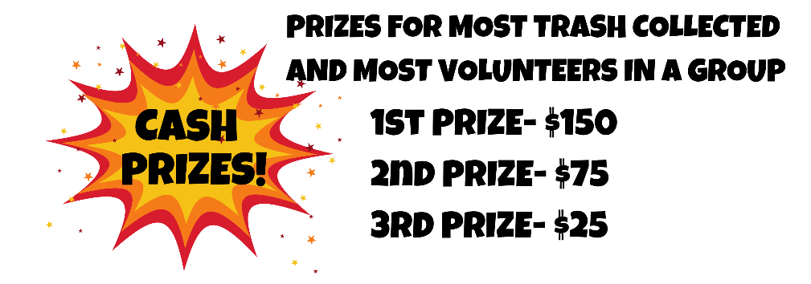
General Safety Notes:
- Make certain all attendees’ cars are parked well off the roadway; avoid parking on the shoulder if possible.
- Please have everyone sign in at the beginning of the event and check out when they leave so no one is inadvertently left alone at the site.
- Please follow standard COVID-19 Safety guidelines as provided by your organization, including wearing masks, social distancing, and using hand sanitizer.
- Beware of traffic. We recommend at least one individual wear a safety vest or other reflective gear, and that individual to be present near the roadway area when others are present, as many areas will require walking on the shoulder to get to the bridge access. Post caution signs if they are available.
- Many riverbanks are steep and slick and may have woody debris that presents a tripping hazard. If a piece of trash is difficult to get to, leave it and move on.
- We strongly suggest each crew have a first aid kit available.
- Know the street address of the site in case of emergency.
- Gloves and vests are encouraged.
- Remember, while this is a clean-up, the first priority is safety. If any unsafe conditions exist (high water, storms, unsafe access, etc.), please be prepared to reevaluate your plan.

More Cleanup Resources:
NC DOT Litter Sweep Information

